Kreuzworträtsel

1

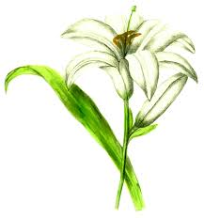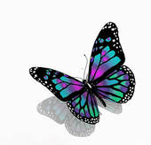[](http://www.google.com.br/url?sa=i&rct=j&q=tulip+clipart&source=images&cd=&cad=rja&docid=yNMcOmDRPqeLnM&tbnid=UTHe0q_xYBZBBM:&ved=0CAUQjRw&url=http://www.123rf.com/clipart-vector/white_tulip.html&ei=iIIbUdijCIXc8ASmv4CQDw&bvm=bv.42261806,d.eWU&psig=AFQjCNEMfXUQ9A_tKhap9K8na69pXzzy5w&ust=1360843756496397)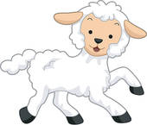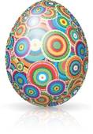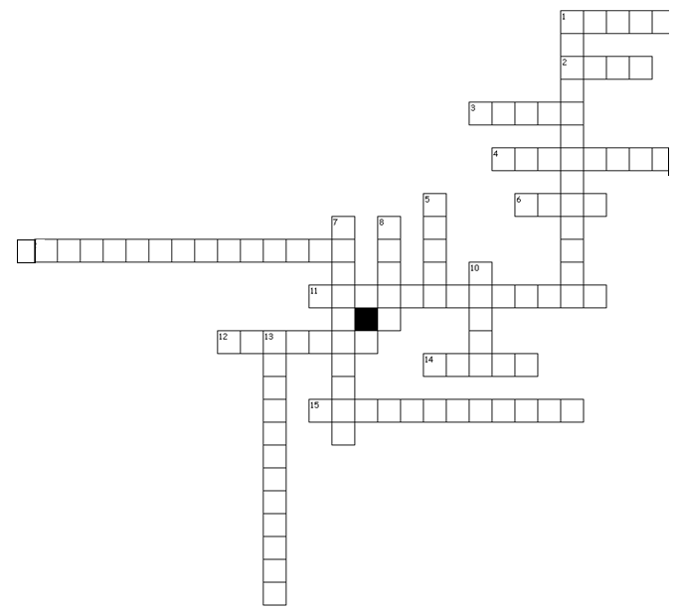

13

12

9

5

1

8

6

4

3

2



15





9

3

14

6

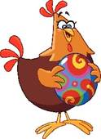

10

14

11

7

9