BUCHSTABENSALAT

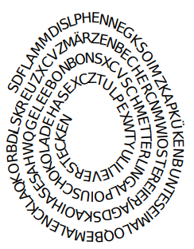

**Finde in der Spirale 16 Wörter, die mit Ostern zu tun haben und vervollständige die Liste .**

1. ......................................
2. ......................................
3. ......................................
4. ......................................
5. ......................................
6. ......................................
7. ......................................
8. ......................................
9. ......................................
10. ......................................
11. ......................................
12. ......................................
13. ......................................
14. ......................................
15. ......................................
16. ......................................

6

2

7

5

3

4

1

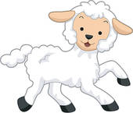 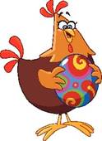 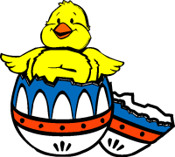 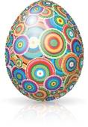 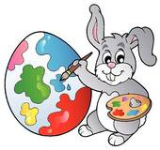 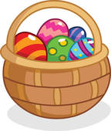 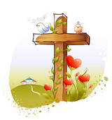

10

16

15

14

13

11

9

8

12

[](http://www.google.com.br/url?sa=i&rct=j&q=daffodil+clip+art&source=images&cd=&cad=rja&docid=_5OPwwP53oGsKM&tbnid=cJUBPlchVNtzUM:&ved=0CAUQjRw&url=http://www.clker.com/clipart-2545.html&ei=ewoZUf7LOJDW9QTiroCYAg&bvm=bv.42080656,d.eWU&psig=AFQjCNGTdqM0UJ44FHmi7Sb8_qPp1cyasA&ust=1360681972129369)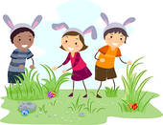  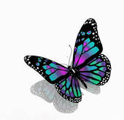[](http://www.google.com.br/url?sa=i&source=images&cd=&cad=rja&docid=KwqlwJ4c09LCBM&tbnid=d4-zyt6bspepSM:&ved=0CAgQjRwwAA&url=http://www.clker.com/clipart-11161.html&ei=QAoZUa2hM4ne9ASYwIH4AQ&psig=AFQjCNFdjOFyBeGENe_7uYqeUFXFHoMK8Q&ust=1360681920911706) 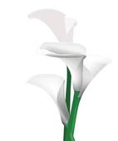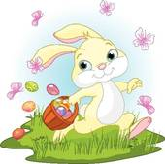

2