OSTERN

[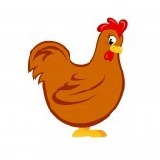](http://www.google.com.br/url?sa=i&rct=j&q=HEN+clipart&source=images&cd=&cad=rja&docid=lMnozjlpA2JHDM&tbnid=Lm3J_x8z6iETgM:&ved=0CAUQjRw&url=http://www.123rf.com/clipart-vector/young_hen.html&ei=_DNDUe7KLYf49QSC_oHYDg&bvm=bv.43828540,d.dmQ&psig=AFQjCNHvKHUja2Iovxtb_pX9eE-ONOWTWQ&ust=1363445043344119)[](http://www.google.com.br/url?sa=i&rct=j&q=BUTTERFLY+clipart&source=images&cd=&cad=rja&docid=ZFFGtVeuqWzdJM&tbnid=yfkVby1qqJ5YYM:&ved=0CAUQjRw&url=http://www.clker.com/clipart-15392.html&ei=RDNDUZfoJoa08QSurYHoDA&bvm=bv.43828540,d.dmQ&psig=AFQjCNEQrYHU1hSRb8CYbQ4PujrHRbYFqg&ust=1363444924161104)[](http://www.google.com.br/url?sa=i&rct=j&q=JELLY+BEANS+clipart&source=images&cd=&cad=rja&docid=aQYY8a6L6CE2XM&tbnid=DkAGomOwKt9AjM:&ved=0CAUQjRw&url=http://motoki-y.sakura.ne.jp/en/illust/food-okashi.shtml&ei=YDJDUePNFIj28gT3hoGwDw&bvm=bv.43828540,d.dmQ&psig=AFQjCNGebRQnz6_lDl4-imS4hal99mbevg&ust=1363444685088885)[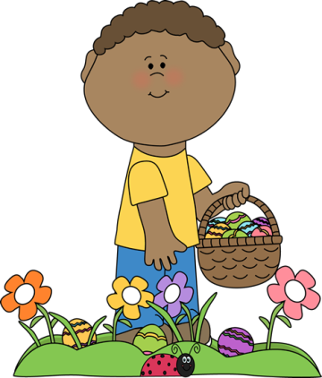](http://www.google.com.br/url?sa=i&rct=j&q=EGG+HUNT+clipart&source=images&cd=&cad=rja&docid=otYuMLn7hCywMM&tbnid=U-dsbC8v_v3vWM:&ved=0CAUQjRw&url=http://www.mycutegraphics.com/graphics/easter/boy-on-easter-egg-hunt.html&ei=zDJDUZWLD5DW9ASS04GgDQ&bvm=bv.43828540,d.dmQ&psig=AFQjCNFhbgjJ5Fmt7RuNuAh5IEN1eIPFeg&ust=1363444772108811)[](http://www.google.com.br/url?sa=i&rct=j&q=CHOCOLATE+BUNNY+clipart&source=images&cd=&cad=rja&docid=DEg059yk_98a1M&tbnid=eUs_BTia5e6aOM:&ved=0CAUQjRw&url=http://www.gograph.com/illustration/happy-easter-day-chocolate-bunny-rabbit-gg57824864.html&ei=6TFDUfm1MovA9QSB04HABA&bvm=bv.43828540,d.dmQ&psig=AFQjCNFRU1Ftk-Lg3tEIM0mReQiVRiDFlA&ust=1363444452945551)[](http://www.google.com.br/url?sa=i&rct=j&q=EASTER+BUNNY+clipart&source=images&cd=&cad=rja&docid=g5JwdfN0B0IG0M&tbnid=xKcKiRO41zELpM:&ved=0CAUQjRw&url=http://www.computerclipart.com/computer_clipart_images/easter_basket_with_a_bunny_and_colored_eggs_0515-1003-2902-0038.html&ei=zzBDUaSEC4Wa9QSs_YBI&bvm=bv.43828540,d.dmQ&psig=AFQjCNFgmbYjVsz1Q9vuamiYn7bX7_xCUw&ust=1363444235594966)[](http://www.google.com.br/url?sa=i&rct=j&q=CROSS+clipart&source=images&cd=&cad=rja&docid=7mJ4Ksen-Buo9M&tbnid=eYgejsusBeCoSM:&ved=0CAUQjRw&url=http://gladlylistening.wordpress.com/tag/holy-week/&ei=ly9DUdb_GoiE8ATojoC4Ag&bvm=bv.43828540,d.dmQ&psig=AFQjCNE7X6NUEMjTphErC-C-82mgbFlb3Q&ust=1363443975111291)[](http://www.google.com.br/url?sa=i&rct=j&q=TULIPS+clipart&source=images&cd=&cad=rja&docid=xafVnzAlup2bgM&tbnid=j9WyX8RnujxC0M:&ved=0CAUQjRw&url=http://www.free-clipart-pictures.net/spring_clipart.html&ei=Ai9DUcHtF4fE9gTD64GoDA&bvm=bv.43828540,d.dmQ&psig=AFQjCNELHVWZ_0H0hsxdbk4JR9UXhxYI1A&ust=1363443835518473)[](http://www.google.com.br/url?sa=i&rct=j&q=DAFFODILS+clipart&source=images&cd=&cad=rja&docid=9VzulQajHboB0M&tbnid=4YTxkW7zcVUOsM:&ved=0CAUQjRw&url=http://www.arthursclipart.org/flowers/flowers/page_03.htm&ei=nS5DUdLTGJGY8gSLpIDoCQ&bvm=bv.43828540,d.dmQ&psig=AFQjCNFHC14-pApmu-XvdcmMikWVJ9Ej_w&ust=1363443733861503)[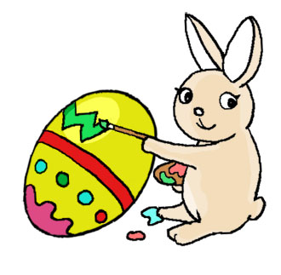](http://www.google.com.br/url?sa=i&rct=j&q=easter+bunny+clipart&source=images&cd=&cad=rja&docid=3Sanx5ZK1JQ5PM&tbnid=74CJc4yNJJzP4M:&ved=0CAUQjRw&url=http://bestclipartblog.com/23-easter-bunny-clip-art.html/easter-bunny-clip-art-2&ei=Py5DUcOQK4Ku8ATRx4GwDQ&bvm=bv.43828540,d.dmQ&psig=AFQjCNGC5Mqoy1mm34LPXq-Mo1Bf-WgZFA&ust=1363443627509102)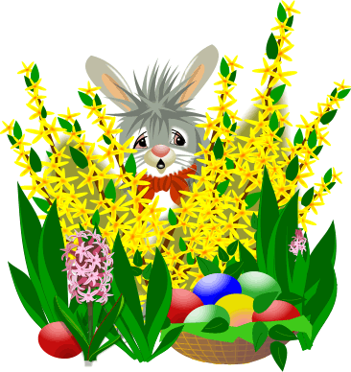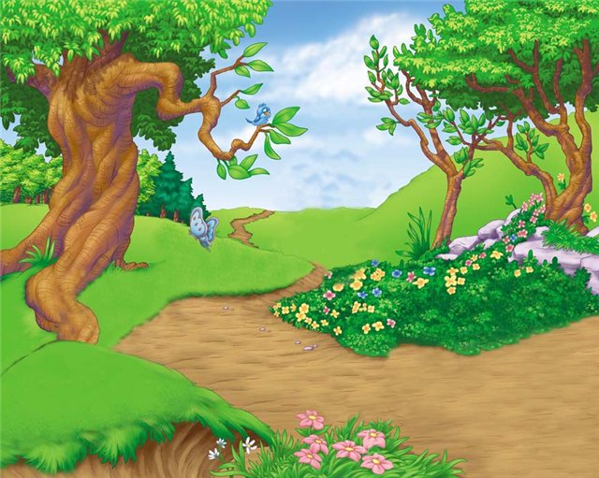

DAS KREUZ

DIE HENNE

BEMALEN

DIE LILIEN

DER SCHOKOLADEHASE

DIE BONBONS

VERSTECKEN

DIEOSTERGLOCKEN

DIE EIERSUCHE

DER SCHMETTERLING

DER HASE

DIE EIER

DER KORB

DAS KÜKEN

DIE TULPEN