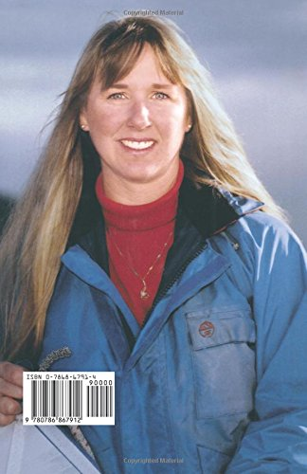
UNIT 4: Project. Real-life heroes
https://www.youtube.com/watch?v=4xUaNtKroPU

Tami Oldham Ashcraft
- What happened to Tami and her fiancé?

- How long was she unconscious?

- Where was she heading to at the end?

- What was the hardest part for her?

Tami Oldham Ashcraft

On October 12, 1983, Tami Oldham Ashcraft and her fiancé, Richard Sharp, found themselves in the path of Hurricane Raymond as they sailed a 44-foot yacht across the Pacific Ocean. The experienced sailors were delivering the luxury boat Hazana from Tahiti’s Papeete Harbor to San Diego on what was supposed to be a routine passage. Instead, the Category 4 storm whipped up violent waves and catastrophic winds that eventually capsized the small craft. In the ensuing chaos, Ashcraft suffered a serious head injury that rendered her unconscious for 27 hours. When she awoke, Sharp was gone.

Alone at sea and awash with grief and shock, Ashcraft mustered the courage to guide the battered Hazana toward the nearest landfall—1,500 miles away, in Hilo, Hawaii. She worked furiously to rig the one remaining sail and a partial spinnaker pole to gain steerage for the boat. Since the electronics were shot in the flooded vessel, Ashcraft had to rely on a sextant and a watch to navigate across the open ocean. “I ran the risk of being off the latitude of Hawaii, so that was always really heavy on my mind,” she says. “If I did not get to Hawaii, I would die.”

Despite scarce rations and serious injuries, Ashcraft made it to Hilo Harbor 41 days later

Tami On Dealing with Grief and Survival at the Same Time:
“I had to talk to myself and tell myself, ‘I have to quit crying.’ I had to quit crying because I was losing so much water, and I didn’t have a lot of water. A lot of the grief was really muted, really shoved back because of the survival and having to keep pushing forward. It really wasn’t until I was back on land, and I could relax and not have to worry about dying, that the grief started surfacing. It was really, really difficult.”

https://www.youtube.com/watch?v=If2lCD0SQrE

- Zvýrazněné a podržené pojmy –přeložte si do češtiny
- Ke slovům, která jsou zvýrazněná zeleně, napište synonymum či antonymum
- Your task for this week is to create at least one page of A4 about your own hero. Please attach pictures, description of your hero and some tasks- you can follow my project. Až bude zase výuka, budeme o těchto projektech diskutovat ve třídě. Až budete projekty tvořit, můžete se inspirovat mým projektem. Připravte si nějaké úkoly pro zbytek třídy. Přiložte fotky a popis hrdiny.
- Spoj obrázky, jak si myslíš, že šel příběh chronologicky. Čerpané z filmu ADRIFT. Doporučuji se podívat.

