- Vybarvi dle instrukcí:
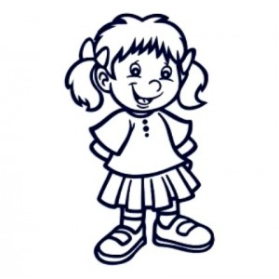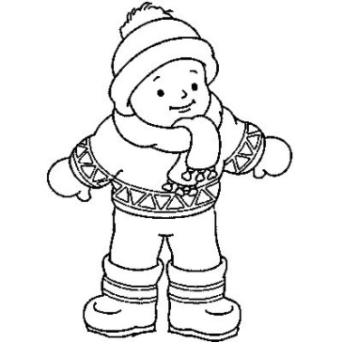
She has got a red T-shirt, a pink skirt, yellow socks and green shoes. He has got blue trousers, a purple hat, brown shoes and a black jumper.
- Doplň do textu: have, sorry, got, here, haven’t, blue
Have you ___________________ a green T-shirt? Yes, I ___________________ . ___________________ you are.
Have you got a ___________________ jacket? No, I ___________________. I’m ___________________.
- Pokládej věty:
skirt got Have a yellow you ?
___________________________________________________________________________
have Yes I . ____________________________________________________
this coat Whose is ?___________________________________________________
- Přivlastňuj osobám podle vzoru: mum - mum’s glasses
John 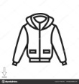 _________________________________________
Jane __________________________________________
dad __________________________________________
sister 

